**Indian Population opening success path or failures’!**

This has been a traditional belief that Indians are poor and not developed much because of the growth in popularity but why is this not the same situation with China?

Countries may be developed or underdeveloped or developing. For an underdeveloped country, it is a hardship to manage population growth as most of the population in such a case is illiterate that gives rise to economical crisis due to the loss of better job opportunities. However, in the case of a developing country with a skilled population, this increased ratio can be an asset to provide a human resource for various innovations and the development of the nation. And, as for the developed countries, on the other hand, they have the maximum literacy rate and that blended with high population ratio can be the best opportunity that can be present for maintaining their success pattern and trends.

India is the second most populated country after China with a population of about 135.26 crores. Managing such a huge population is a strategy that is to be achieved for better success and growth Trends. China being the largest country with the highest population has managed to transform its human resource into an asset for the country.

With digitalization upcoming due to COVID-19 pandemic, skilled and talented human resource is what every country is requiring for various technological and software advancements to help support the country in the time of such a big need. This justifies how skilled human resource is an asset for any country.

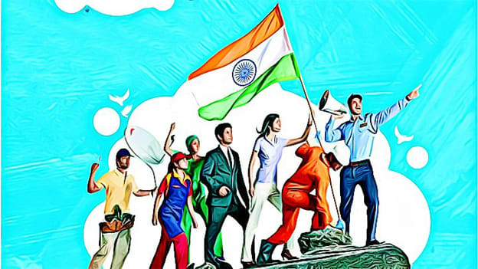

Many Tech Giants like Google and Facebook have promised to invest about billions of amount into the Indian industry and with such a huge amount and a lot of skilled folks, India can be a golden bird again.

But the question is that how is India going to manage this much population and how are they going to strategize for converting its human resource into an asset? Is human resource in asset or liability?

On the Independence Day celebration of the Year 2020, Prime Minister Narendra Modi himself showed the concern about population explosion and how this is a challenge to be managed! He also continued that parents need to analyze their incomes and other resources before extending their family and having more babies.

At present, more than 50% of the Indian population is below 25, and with this, it is a basic scenario of how the increase in the number of young population in the country is going to give rise in the population growth eventually in the upcoming future. However, this is not an issue that has to be acknowledged! The issue to be taken care of is that how literacy and more education can be provided to the young generation to ensure more and more workforce and hence better innovations and success rates in the country.

As stated by various statistics, every year India produces 2.5 million IT engineers and life science graduates and just imagine how this much of the educated and skills individuals can bring lots of innovations into the country opening the doors for its monstrous development and success.

But, with the illiteracy persisting in the country, and literacy rate not getting any boost, it is a point to be analyzed on how these many illiterates are managed and what would be the economic resource for them! Illiterates get to work as third-class workers or laborers. And, how will this bring India as a developed nation? Focusing on education and Healthcare facilities can enhance the development of the growing population and this can be an asset for India to be a developed nation in the next few decades.

By maintaining the education, skill, healthcare, and alertness among the citizens, amidst the Corona pandemic, India can transform its patterns and strategize to transform its huge population into an asset.

With Galwan clash, Uyghur genocides, and the rise of Corona from China, it is a bad contract for everyone and most of the countries want to wipe it away from their markets. The USA has also experienced various life losses with the pandemic. And with various investments and a surge in the number of Unicorns of India, the improvised literacy collaborated with skill in the people can result in India being the next Silicon Valley and a globally recognized innovation center and technological giant.

Indians can conquer the development and mark their reign with perfect strategies and managements and can convert a huge population into an asset. Or, they can just let this opportunity vanish and be a huge liability for the nation!

